Dear all coworkers Date – 4th August 2016
Greeting you from KRC.
On behalf of KRC, would like to invite you all to KRC & Partners quarterly meeting which will be held on 25th August 2016 in KRC office Mae Sod. Time will be as- 9:00-12:00 am . Your present are appreciated .
The draft agenda will be as follow:
- KRC briefing – update information
- ARC new activities or update information
- Volunteer Return Center of UNHCR & IOM
- Food Card Program in Nupo Camp & other - TBC
- Ongoing process on Suicide cases – PUI ( PU AMI ) & SMRU
- Child Protection issue – COERR & UNHCR
- Youth Program in Camp – Right To Play or any Agency that work on it.
- The rest of Agencies will update us on their activities where necessary.
We KRC really would like to meet you in this meeting as we will continue our new term, on your activities in the camps. Our pleasure is if al the agencies who are working in the camps are there in the meeting.
Kindly ask a favor to CCSDPT to pass this invitation to all of the agencies for their information.
Hope to see you soon.
In Peace
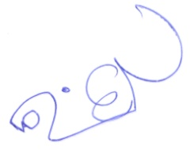

Blooming Night Zan
Finance Managing Officer
Karen Refugee Committee
Mae Sod
Phone - +66 88 5455 746
Email- z_blooming@hotmail.com
To The Better Life of Refugees

